PROJECT INITIATION DOCUMENT

SOUTH YORKSHIRE BUSES (SYB) JOURNEY PLANNER

| Ross Feeley | Ammar Ahmad | Wesley Atkinson | Silvia Horoba |
| --- | --- | --- | --- |

Purpose 2

Background 2

Objectives 3

Scope and Exclusions 3

Outline of Deliverables 4

Constraints 5

Assumptions 5

Estimation 6

Business Case 8

Risk Log 9

Project Organisation Structure 10

Project Plan 11

Project Quality Plan 13

# Purpose

This Project Initiation Document (PID) has been created to define and gather essential planning information required to assess and manage a clear plan for the project delivery of the South Yorkshire Buses Journey Planner and its overall success. The document’s primary goal is to address the following fundamental aspects of the project:

* *What is the project aiming to achieve?*
* *What is the project’s scope?*
* *Who will be involved in managing the project, and what are their responsibilities?*
* *How will risk be managed?*
* *What are the constraints encountered?*
* *How will quality be managed?*

# Background

South Yorkshire Buses are a travel company based in South Yorkshire and require an application that will allow them to modernise their customers' travel experience. They need an application to compete with other companies around them that can adapt to modern technology allowing the users to plan their journeys on the go. The company’s current system is outdated, and it is not up to the current standards having multiple faults that cause inconvenience to their customers. The company is also looking to save money on hosting (that currently is going up to £60.000/year), on staff, and on any further updates that would usually cost up to £500/change.

# Objectives

This project aims to create an application that will use the South Yorkshire Buses bus schedule to allow customers to plan their journey effectively and efficiently. The system will need to provide the customers with the times and dates of all buses in the South Yorkshire area and will require us to create an application that can provide this service.

This system will use prototypes to manage the project so that we can get accurate feedback and information about our application to create the best product possible. The main objective is to build a high-quality product that will work fast and efficiently while keeping the lowest costs viable when it comes to maintaining it.

# Scope and Exclusions

Initially, the application will consist of features that will allow the user to check the times of buses around his area. The software will provide information such as *when is my next bus, what buses are available at my location, and what is the best ticket to buy.* The scope of the prototype is to allow users to choose their destination (either through a map or by adding the location manually) and be presented with a step-by-step route on how to get there through different modes of transportation (not only by bus). Furthermore, the system will provide live travel updates and alternative options in extenuating circumstances (e.g., road closures, accidents).

The ticketing system will be included in the final prototype, making it available for the users to check for the best price and purchase any ticket.

As part of launching the Journey Planner, a one-month application review will be expected. This will then answer any post-launch issues users have been experiencing. We assume that any further updates will be handled by South Yorkshire Buses.

# Outline of Deliverables

As part of this project, the deliverables will reflect the research conducted and the client's existing app solution. Several documents will assist in the development and success of this project.

Management Deliverables

1. Project Initiation Document
2. Business Case
3. Project Plan:

a) Product/Work Breakdown Structure

b) Gantt Chart

1. Project Management Strategy
2. Risk Management Plan
3. Quality Plan
4. Envisioned Solution

Design Deliverable

1. Wireframing
2. Prototyping Documentation

Development Deliverables

1. Development
   1. Development Sprints
2. Testing

This project will ultimately result in a mobile app that allows users to book journeys, check bus locations, check live travel updates, and determine what tickets to purchase.

# Constraints

One of the main constraints of the project can be defined by the unclear scope we have been presented with. Over our client meetings, we gathered the information needed to build an application that would comply with the client’s expectations. The project’s budget of £60,000 can determine another important constraint, along with the timeline. The final application is set to be launched on the 31st of March, 2023. As the initial budget includes external and internal expenses, it could constrain the timeline and quality of the project.

A slightly more overlooked restraint is acknowledging other competitors on the market. We need to build software that can compete with similar products and appeal to new customers.

# Assumptions

1. South Yorkshire Buses will cover all costs associated with running the application once it has been created, such as costs for hosting and API calls.
2. The data required for such an application will be available through a paid API such as Google Maps/SilverRail.
3. No data will be stored about the application users, meaning that we do not have to worry about GDPR.
4. The journey planner should be downloadable as a native mobile app, with data such as bus timetables available without an internet connection.
5. SYB will provide data for their buses, such as bus times, locations, and ticket prices.

# Estimation

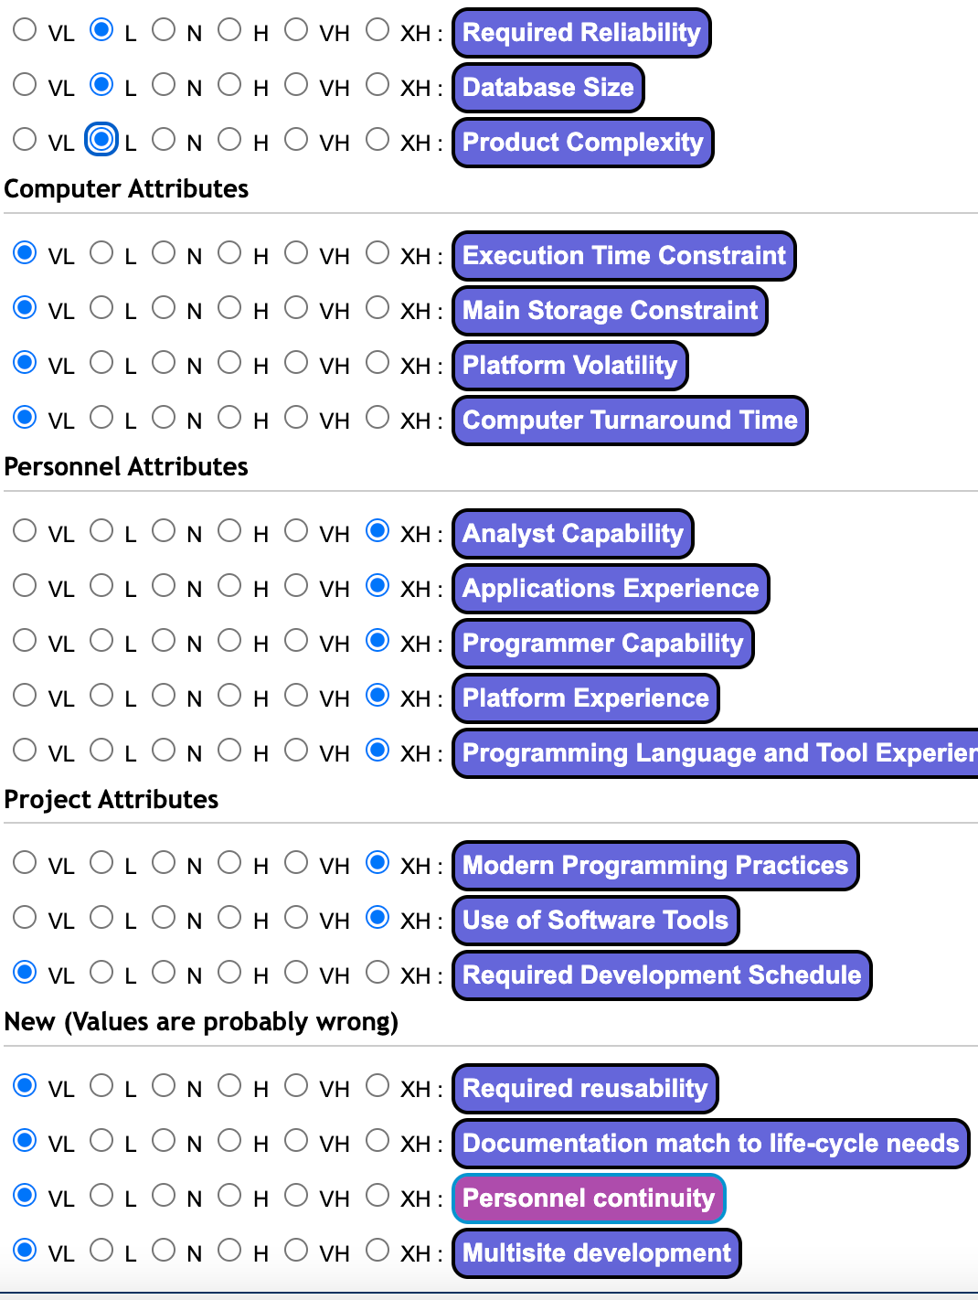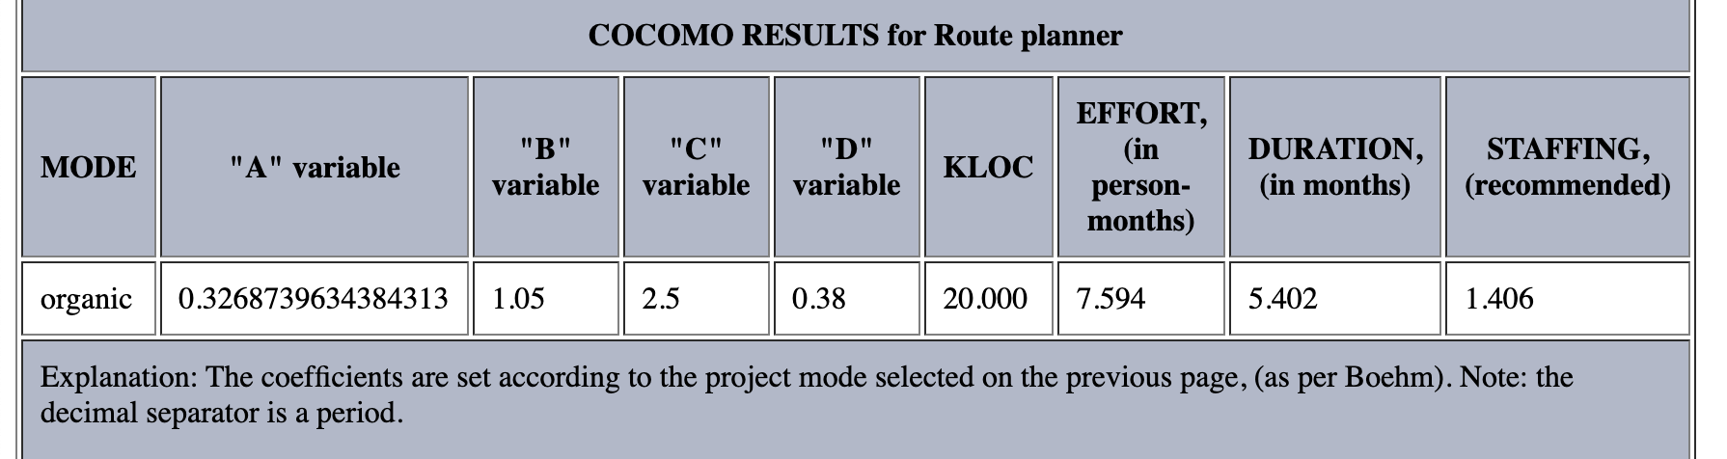

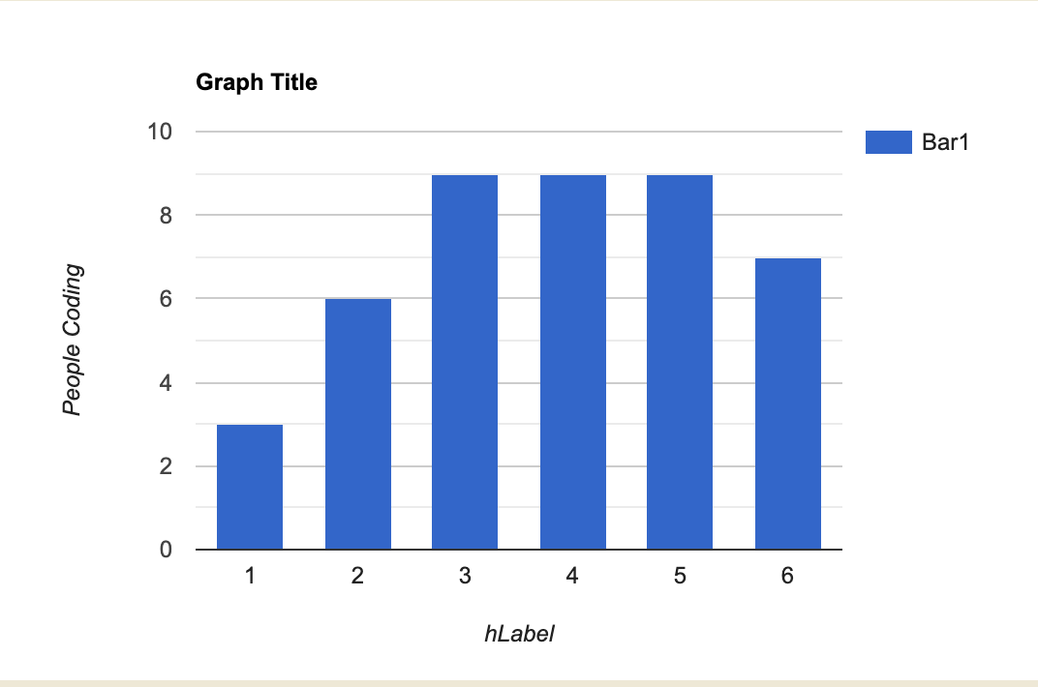

# Business Case

The Business Case oversees our companies’ possible solutions to the financial and technical issues occurring with the current system at South Yorkshire Buses.

The document assesses the following: the business problem and possible solutions, benefits and risks, cost, both outgoing and incoming, the timescale for development, impact, and our capability to develop our solution.

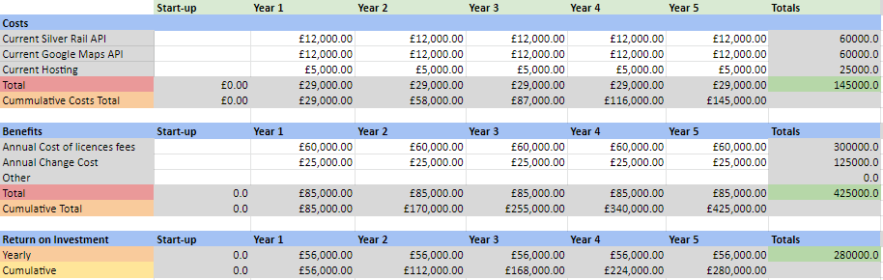

# 

# Risk Log

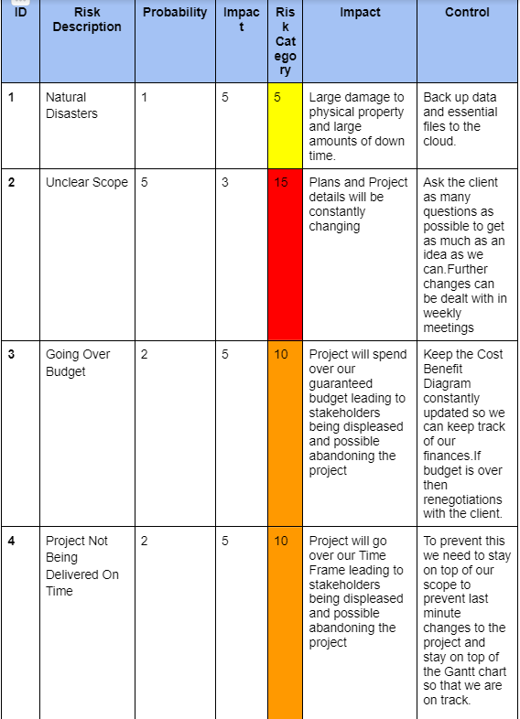

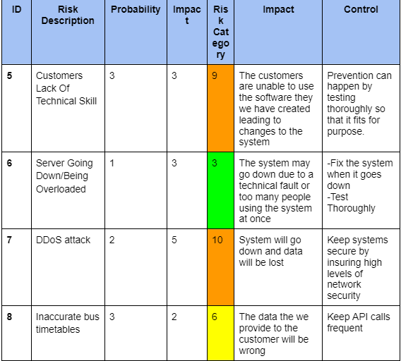

# Project Organisation Structure

# Project Plan

Schedule

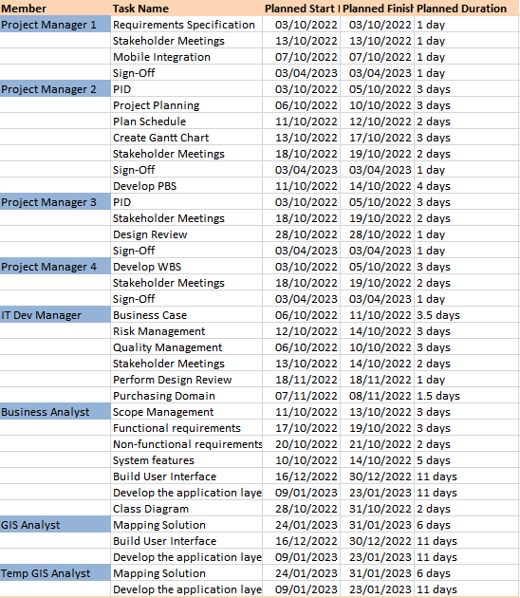

# 

# Project Quality Plan

Quality Requirements

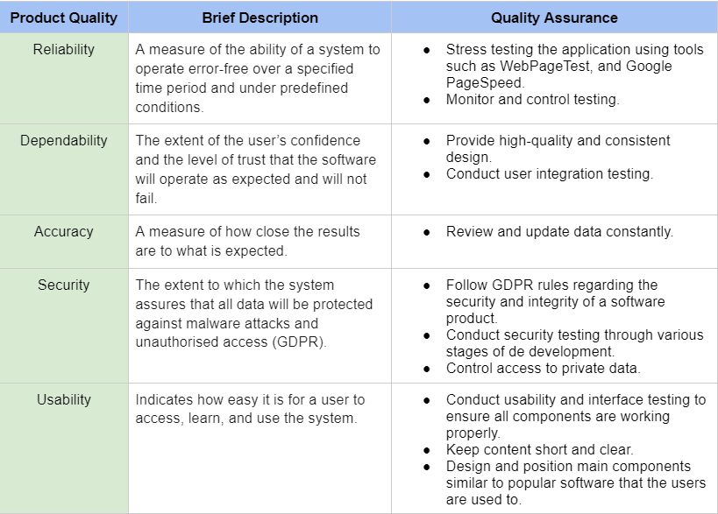

Quality Control Methods

We will be conducting tests to ensure the overall quality of the final product.

The types of tests that will be performed are

* Functionality testing.
* Usability testing.
* Interface testing.
* Compatibility testing.
* Performance testing.
* Security/penetration testing.